

**Touchstones**

***Netcards***

**Generosity Netcards with Text**

Anne Frank HRJ

Barbed Wire HRJ

Begin HRJ

Black and White HRJ



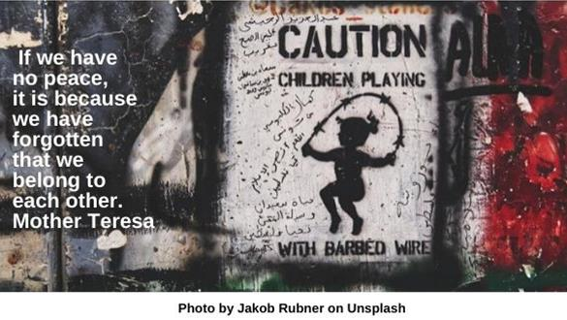

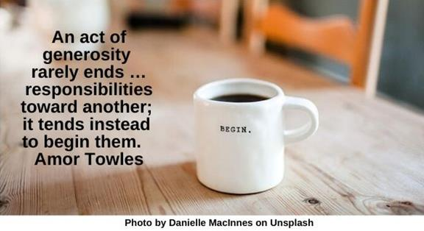



Candle HRJ

Children Walking HRJ

Connections HRJ

Dalai Lama HRJ

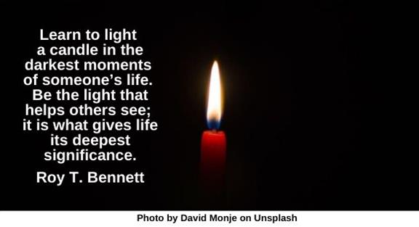

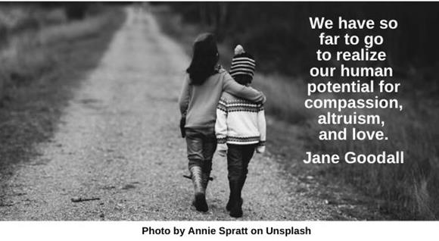

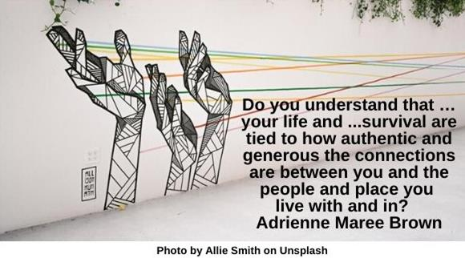

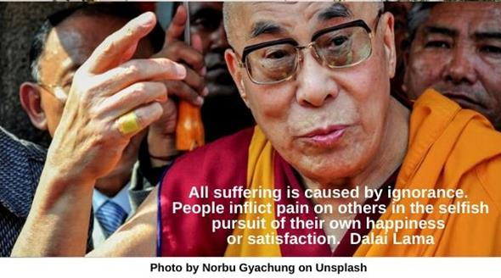

Earth HRJ

Embrace HRJ

Fingers HRJ

Fred Rogers HRJ

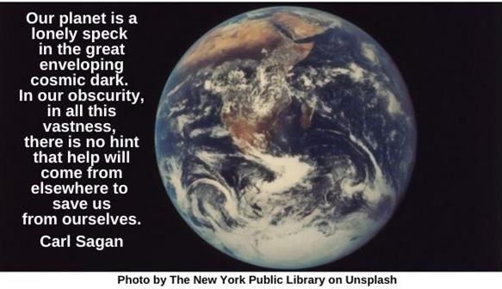

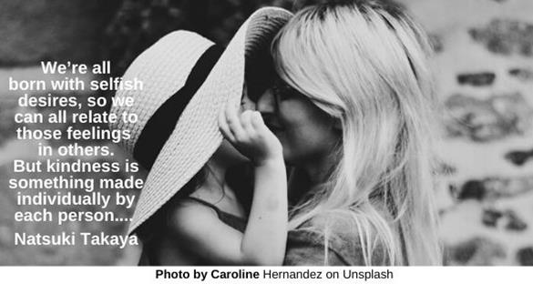

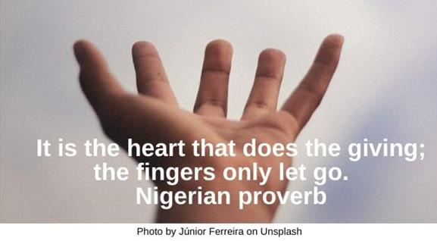

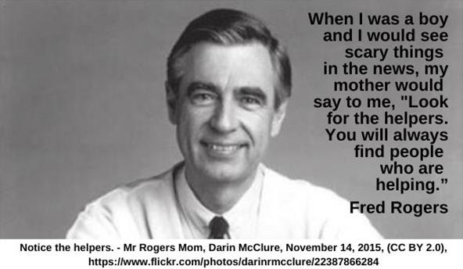

Future HRJ

Garbage Dump HRJ

I Voted Sticker HRJ

Kindergarten HRJ

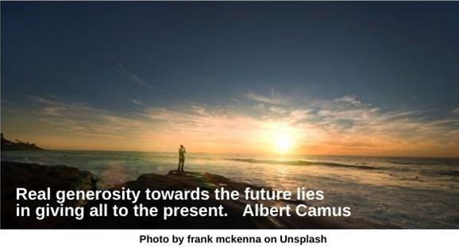

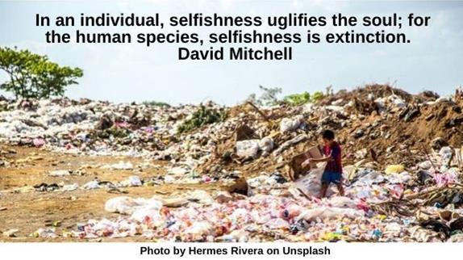

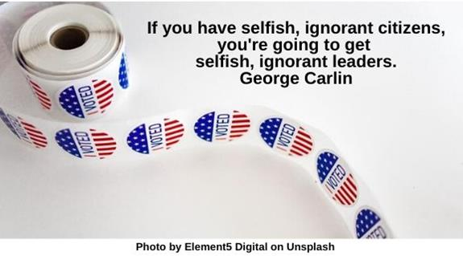

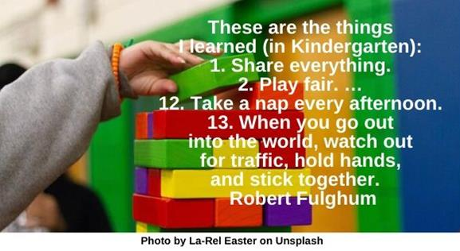

Love HRJ

Mandela HRJ

No Mean People HRJ

Nothing HRJ

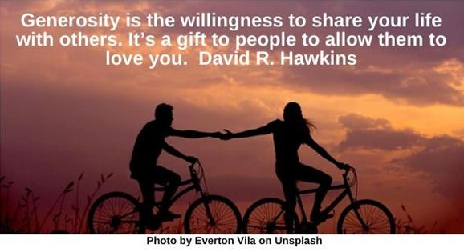

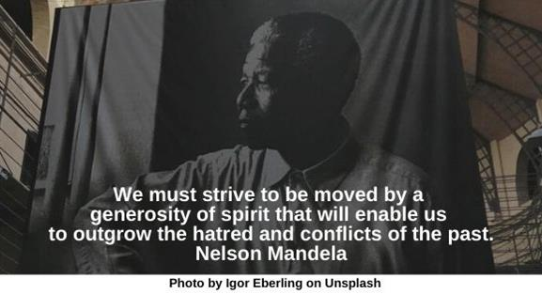

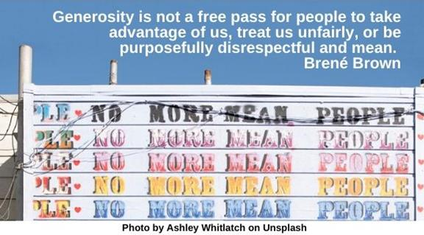

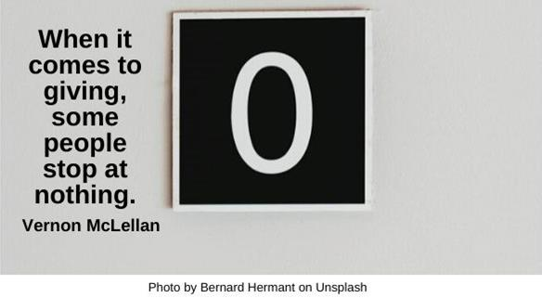

Orchestra HRJ

Piggy Bank HRJ

Plum Tree HRJ

Soil HRJ

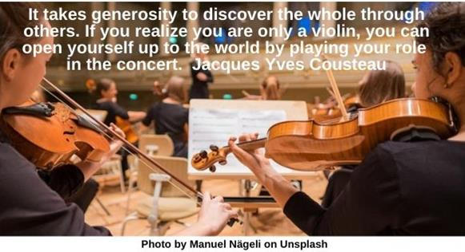

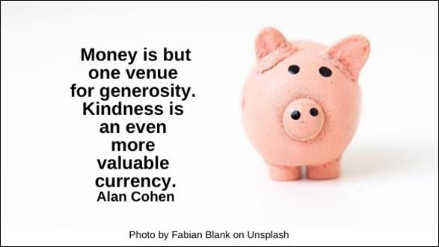



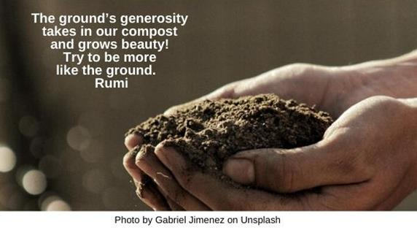

Stuffed Bear HRJ

Taxes HRJ

Teacher HRJ

Tornado HRJ

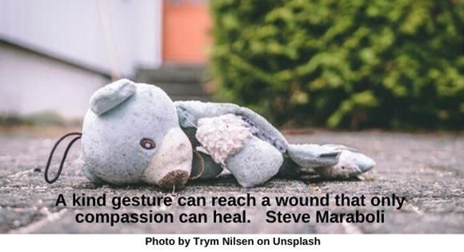



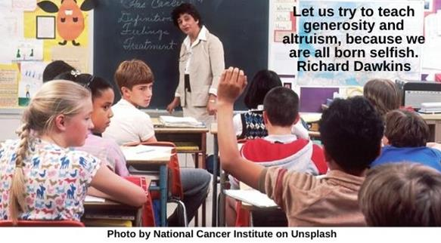

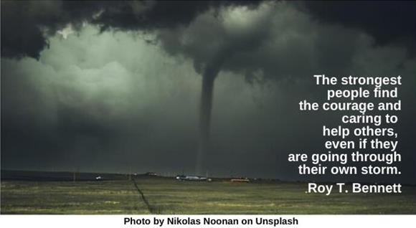

Trees HRJ

Vulnerability HRJ

Winter Sky HRJ

World HRJ

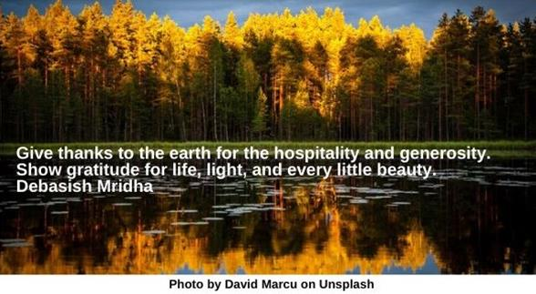

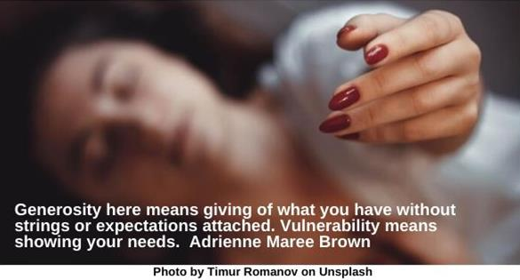

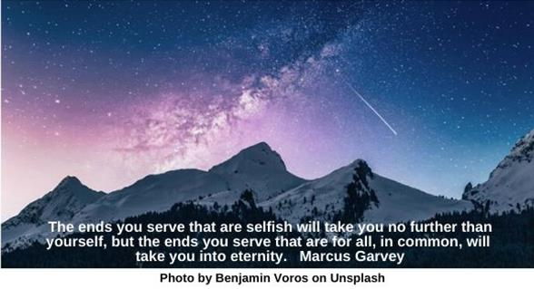

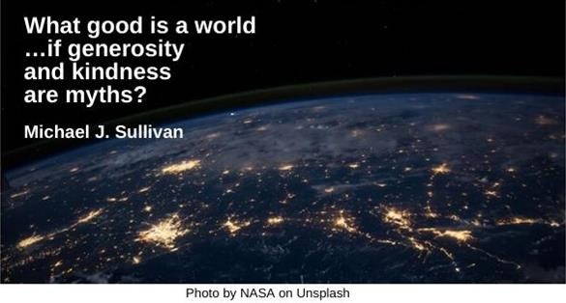

**Text of Quotes**

Anne Frank

No one has ever become poor by giving. Anne Frank

Barbed Wire

If we have no peace, it is because we have forgotten that we belong to each other. Mother Teresa

Begin

An act of generosity rarely ends …responsibilities toward another; it tends instead to begin them. Amor Towles

Black and White

“Every[one] …must decide whether… [they] will walk in the light of creative altruism or in the darkness of destructive selfishness.” Martin Luther King, Jr.

Candle

Learn to light a candle in the darkest moments of someone’s life. Be the light that helps others see; it is what gives life its deepest significance. Roy T. Bennett

Children Walking

“We have so far to go to realize our human potential for compassion, altruism, and love.” Jane Goodall

Connections

Do you understand that …life and your survival are tied to how authentic and generous the connections are between you and the people and place you live with and in? Adrienne Maree Brown

Dalai Lama

All suffering is caused by ignorance. People inflict pain on others in the selfish pursuit of their own happiness or satisfaction. Dalai Lama

Earth

Our planet is a lonely speck in the great enveloping cosmic dark. In our obscurity, in all this vastness, there is no hint that help will come from elsewhere to save us from ourselves. Carl Sagan

Embrace

We’re all born with selfish desires, so we can all relate to those feelings in others. But kindness is something made individually by each person.... Natsuki Takaya

Fingers

It is the heart that does the giving; the fingers only let go. Nigerian proverb

Fred Rogers

When I was a boy and I would see scary things in the news, my mother would say to me, “Look for the helpers. You will always find people who are helping.” Fred Rogers

Future

Real generosity towards the future lies in giving all to the present. Albert Camus

Garbage Dump

In an individual, selfishness uglifies the soul; for the human species, selfishness is extinction. David Mitchell

I Voted Sticker

If you have selfish, ignorant citizens, you're going to get selfish, ignorant leaders. George Carlin

Kindergarten

These are the things I learned (in Kindergarten): 1. Share everything. 2. Play fair. … 12. Take a nap every afternoon. 13. When you go out into the world, watch out for traffic, hold hands, and stick together. Robert Fulghum

Love

Generosity is the willingness to share your life with others. It’s a gift to people to allow them to love you. David R. Hawkins

Mandela

## We must strive to be moved by a generosity of spirit that will enable us to outgrow the hatred and conflicts of the past. Nelson Mandela

No Mean People

Generosity is not a free pass for people to take advantage of us, treat us unfairly, or be purposefully disrespectful and mean. Brené Brown

Nothing

When it comes to giving, some people stop at nothing. Vernon McLellan

Orchestra

It takes generosity to discover the whole through others. If you realize you are only a violin, you can open yourself up to the world by playing your role in the concert. Jacques Yves Cousteau

Piggy Bank

Money is but one venue for generosity. Kindness is an even more valuable currency. Alan Cohen

Plumtree

Don't touch my plumtree!  
Said my friend and saying so...  
Broke the branch for me  
Taigi

Soil

The ground’s generosity takes in our compost and grows beauty! Try to be more like the ground. Rumi

Stuffed Bear

A kind gesture can reach a wound that only compassion can heal. Steve Maraboli

Taxes

Generosity is not always tax deductible. Ken Solts

Teacher

Let us try to teach generosity and altruism, because we are all born selfish. Richard Dawkins

Tornado

The strongest people find the courage and caring to help others, even if they are going through their own storm. Roy T. Bennett

Trees

Give thanks to the earth for the hospitality and generosity. Show gratitude for life, light and every little beauty. Debasish Mridha

Vulnerability

Generosity here means giving of what you have without strings or expectations attached. Vulnerability means showing your needs. Adrienne Maree Brown

Winter Sky

The ends you serve that are selfish will take you no further than yourself but the ends you serve that are for all, in common, will take you into eternity. Marcus Garvey

World

What good is a world …if generosity and kindness are myths? Michael J. Sullivan